**Install Python:**

1. Install the most recent version of Python at [www.python.org](http://www.python.org). I checked the option to add it to my path.

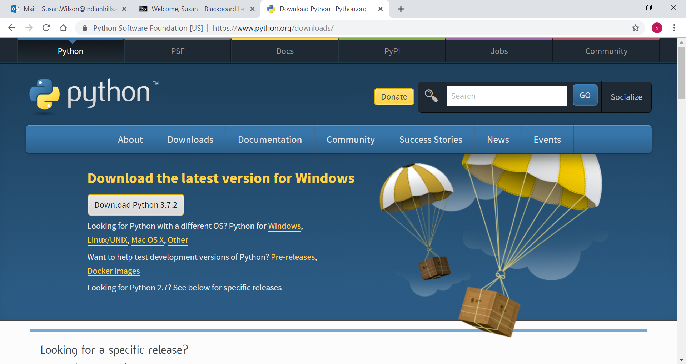

1. To check that python is working, Go to your command prompt. (Search on CMD)
2. Type Python at the prompt, press enter
3. Type the following command: print(“Hello Sunshine!”)
4. Did you get the message???

**Create a project in Visual Studio:**

1. Start Visual Studio
2. Look for Python

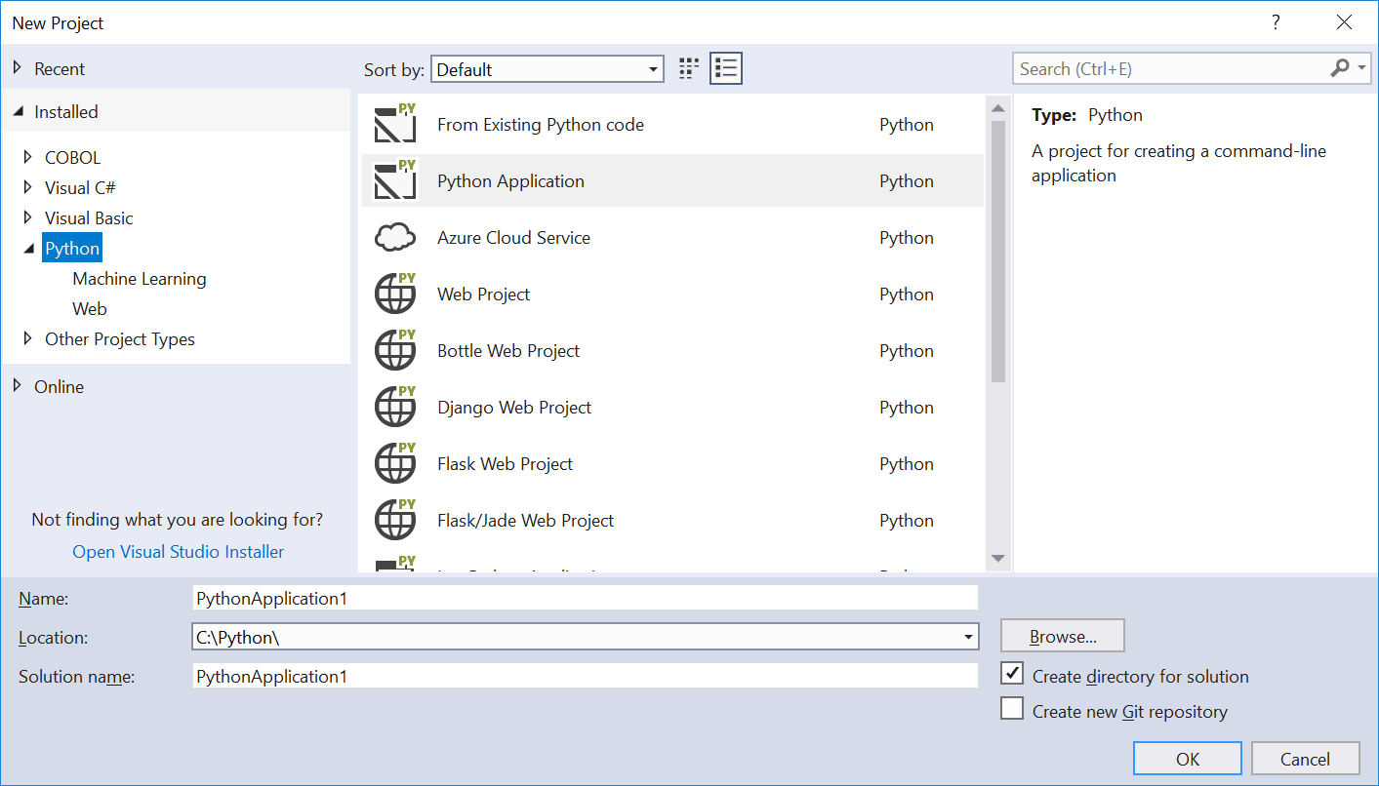

1. If Python isn’t listed, click on the Open Visual Studio Installer
2. Select Python and install
3. Create a folder on your C drive called Python
4. Create a new project in the Python Folder
   1. Choose Python Application
   2. Name it SampleCode
   3. Change the location to C:\Python
   4. Press OK
5. The SampleCode.py file is automatically opened for you.
6. Type the following command: print(“Hello Sunshine!”)
7. Click on the Attach Button
8. 